**ASSIGNMENT 2b – KUBERNETES**

|  |  |  |
| --- | --- | --- |
| NAME: SAHANA RAO | SRN: PES1UG20CS588 | SECTION: J |

1a) Minikube start

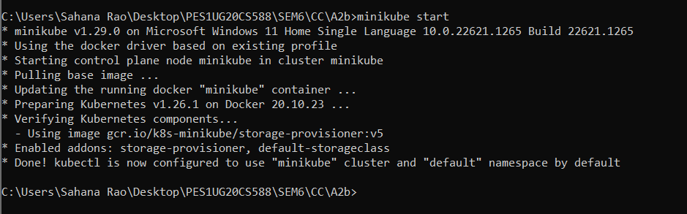

2a) Get nodes, pods and services command

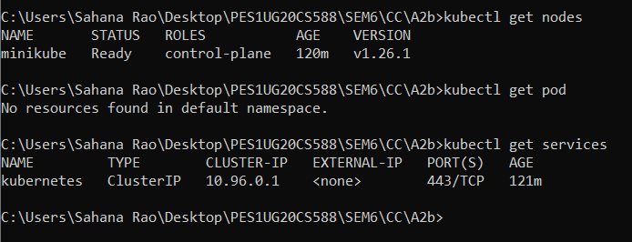

2b) Deployment created

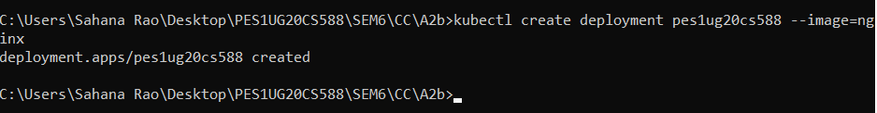

2c) Get deployment and pod command

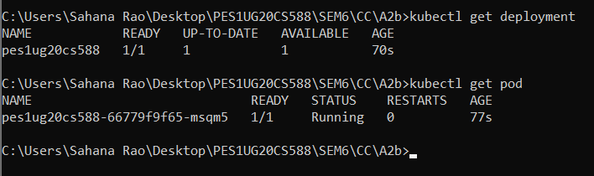

2d) Editing – ‘image: nginx’

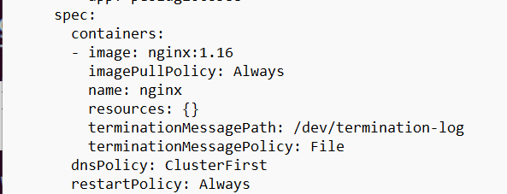

2e) Showing edited deployment



2f) Deployment is rolled back



2g) Showing original nginx image

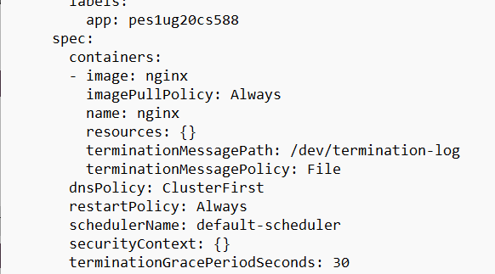

3a) Kubectl logs displayed

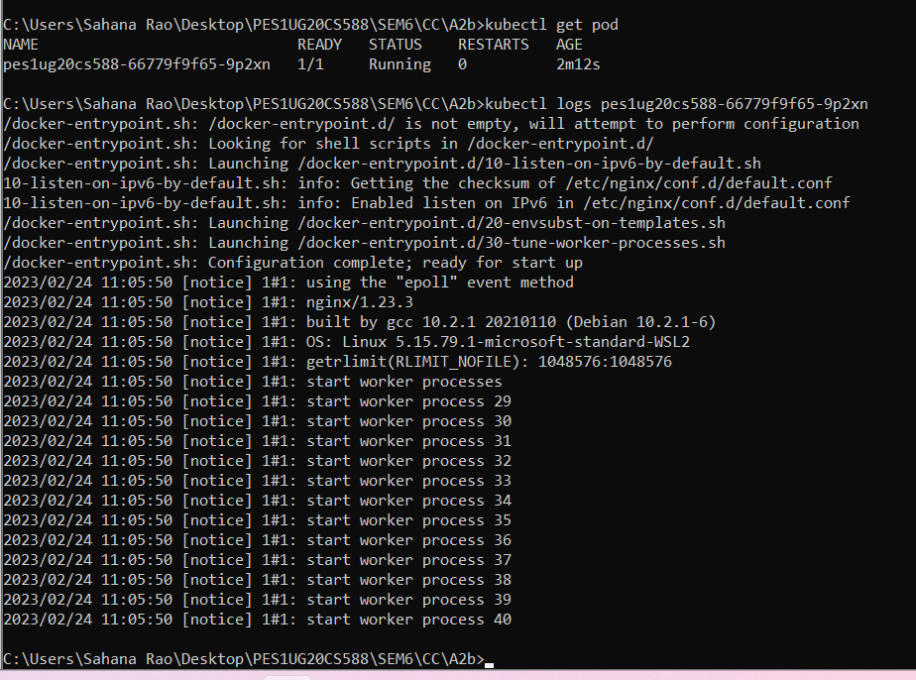

3b) Kubectl ‘describe pod’ command

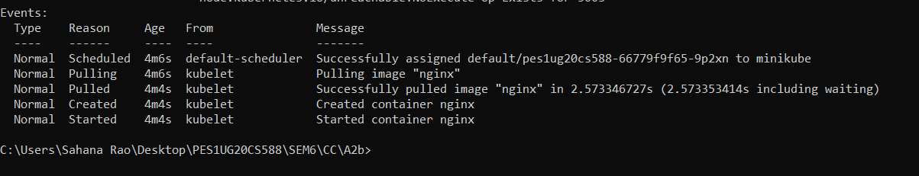

3c) Create mongo deployment

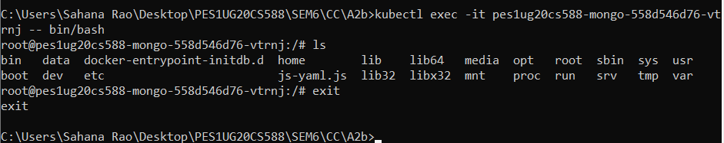

3d) Delete both requirements

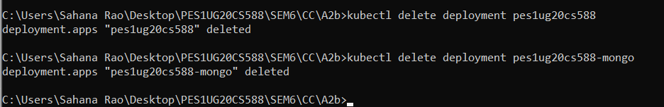

4a) Kubectl apply command on yaml file



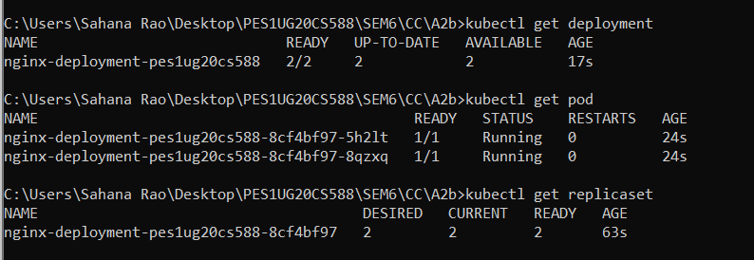

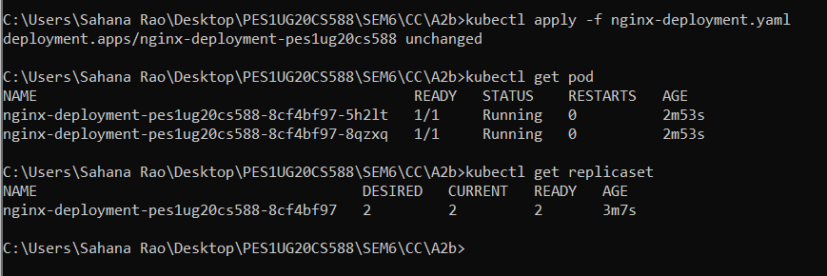

4b) Kubectl get on yaml file

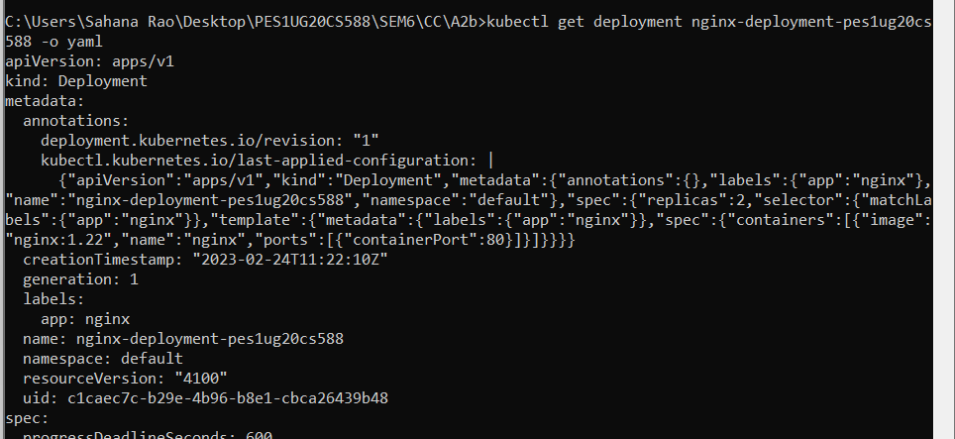

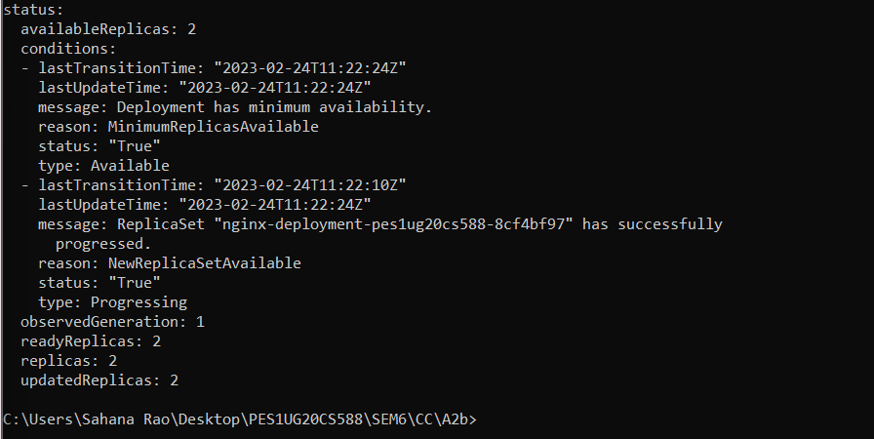

5a) Deleted pod

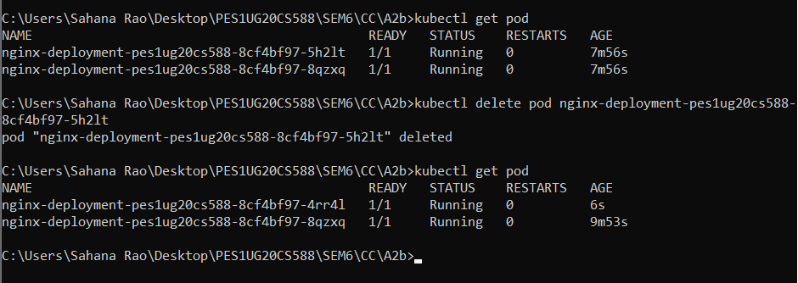

6a) Kubectl apply and get command

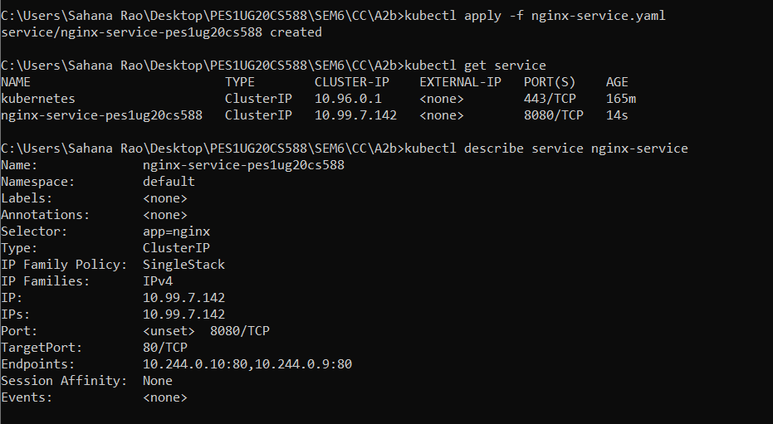

6b) Kubectl get pod -o wide command

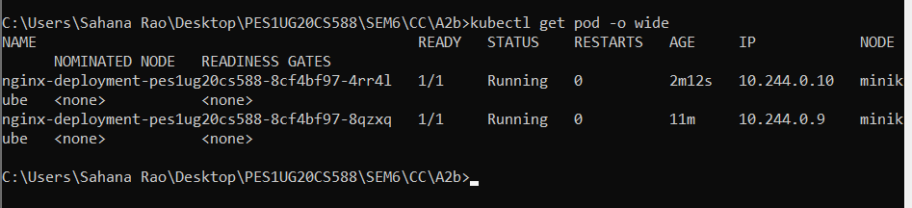

7a) Kubectl port-forward command

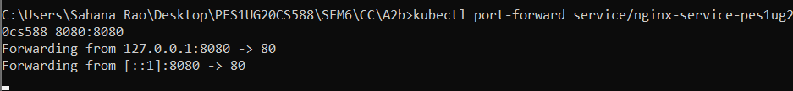

7b) Display welcome to nginx on webpage

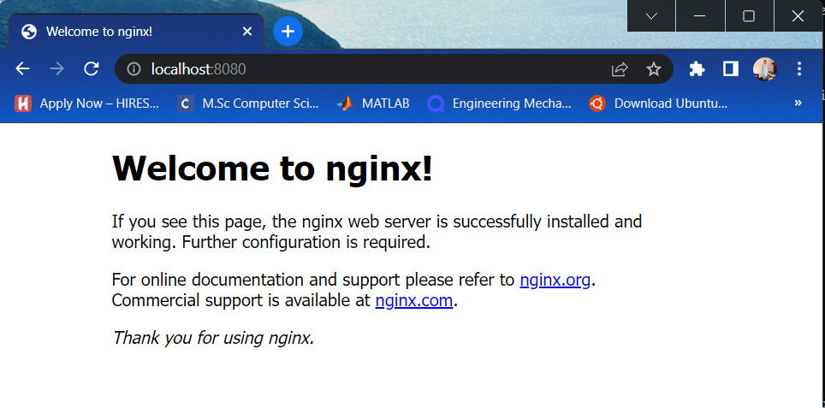

8a) Delete nginx deployments

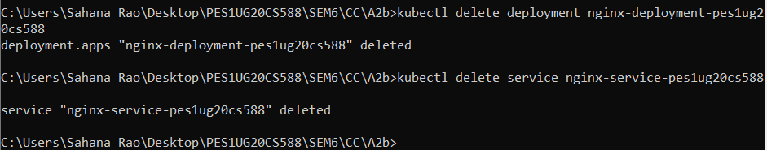

8b) Stop minikube

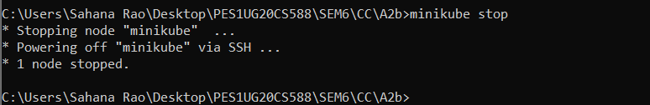

9a) The command which exposes specifies the type of service



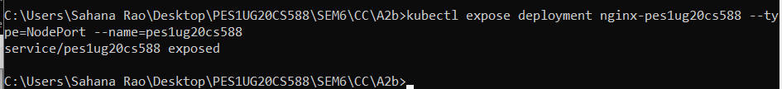

9b) Kubectl get service command which displays the node port

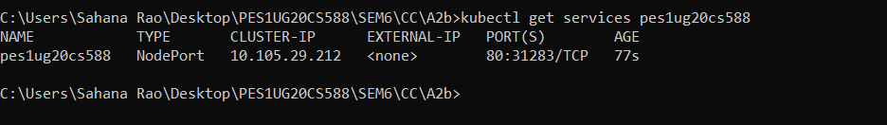

9c) Minikube IP address

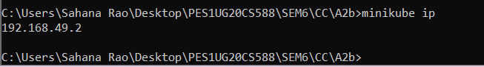

9d) The webpage with the IP address visible

